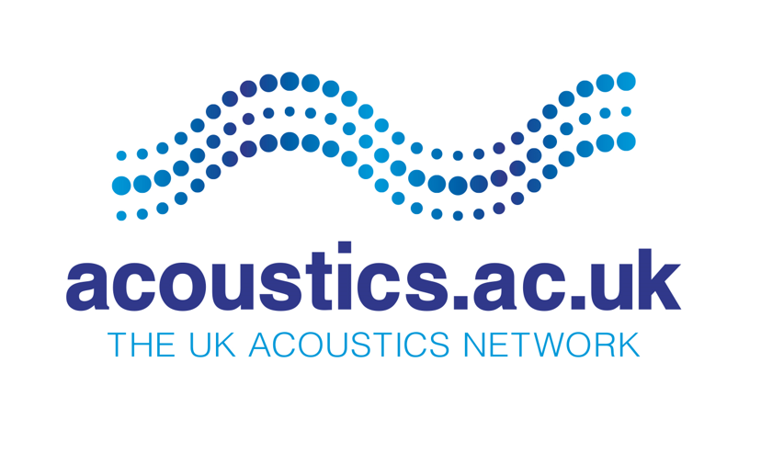
Pilot Projects Final report
Call round: - 1
Pilot Project Title: Acoustic attenuation using advanced nanoporous materials
PI: Yueting Sun | Research Organisation: University of Birmingham
Department: Mechanical Engineering | Start Date: 1st May 2022 | Duration: 8 months
Cost of award (80%): 47,406.62 | Value of co-investment: n/a  In kind: n/a  Cash: n/a
Co-I and associated RO: Dr Jason Raymond and Prof James Kwan, University of Oxford | Acoustic Research themes: New methods for noise control
Collaborations & Partnerships involved in project: Tell us about bi-lateral or multi-lateral partnerships/participation by the PI or research team in a network, consortium, multi-centre study
This project is built up collaboratively between investigators in the areas of nanoporous materials (Birmingham) and physical acoustics (Oxford). During this project, the team engaged industrial partners including the National Physical Laboratory (NPL) and QinetiQ to provide additional expertise and testing facility for the new material system in follow-up projects.

Project Partners
Value and details of in-kind co-investment: - n/a | Value and details of cash co-investment: - n/a
Summary: A summary that can be published on our website (please do consider providing photo/images)
The team investigated the potential of using advanced nanoporous materials for acoustic attenuations. Sponge-like materials such as metal-organic frameworks (MOFs) and zeolites offer extremely small pores that are comparable to the size of water molecules. Squeezing liquid water into these tiny nanopores can create large solid-liquid interfaces and dissipate huge amount of mechanical energy. The team carried out a feasibility study on acoustic attenuation of such materials which may bring ground-breaking technologies.

Objectives: As stated in the original case for support
This explorative project aims to experimentally demonstrate the feasibility of using nanoporous materials for acoustic attenuation. The expected outcomes include (1) validated experimental methods and custom-made testing setups to guide the comprehensive methodology design of the full-scale proposal for a systematic investigation; (2) a few promising candidate materials that are tested to be effective in acoustic attenuation and suitable for further investigation in the full-scale project; (3) some initial understandings or hypotheses on the mechanisms to identify the scientific significance as well as the experimental or simulation techniques required for an in-depth understanding that could be used to develop material design rules for the identified applications.

Outcomes/Impact*: Please refer to stated objectives. What impact has this had on the Acoustics Sector? How are the results being applied? Please provide specific examples/evidence to support the provided statements.
(1) We designed and validated two experimental methods to investigate the acoustic attenuation of the material system, which serves as a foundation for a systematic investigation.
(2) We identified and investigated candidate materials that are effective in acoustic attenuation under certain conditions, opening further investigations into more materials in the full-scale project.
(3) We gained an initial hypothesis on the physical mechanism which guides the direction of further investigations.
This project provides promising preliminary results on using a new class of materials for acoustic attenuation. Such results have not been applied in a practical situation but has a good potential of bringing ground-breaking technologies. The team aims to continue fundamental research in this direction and engage potential research users to develop application case studies and demonstrators in the next stage. PI is recently awarded the UKRI Future Leaders Fellowship (FLF) related to this project which can facilitate the wider impact delivery from this project.
*What activities have you undertaken to engage with research users, special interest groups and the general public to inform them about the research?  Conferences and seminars:  - Talk on Internoise2022 (Glasgow) to disseminate the work to the acoustic community, including UKAN members and potential industrial partners.  - Talk on HYMA 2022 (Genova, Italy) that built new collaborations with a number of chemists and material scientists offering new porous materials.  - Lecture to the Solid Mechanics and Material Engineering, at the University of Oxford, 2022.  Public engagement:  - Hosted an In2Science UK student in the summer and was awarded the ‘Host of the week’.  - Talk at a student career forum in Oxford by OxfordCSSA  - Interviewed by the Tsinghua Student Association of Science and Technology about research & innovation.  Interaction with other fields and sectors:  - Actively engaged in FLF events including annual conference and crucible program to talk to other FLF fellows in different disciplines and UKRI about work related to this project.  - Reach out to potential industrial partners, e.g., QinetiQ. | *Have any new research tools or methods been created or commissioned, if so, provide details: -  Within this project, we designed and validated two kinds of experimental methods to investigate nanoporous material systems at different conditions.
*What activities have you undertaken to engage with research users, special interest groups and the general public to inform them about the research?  See above. | *Have any new research datasets, databases and models making, or potential to make, significant difference to your research (or that of others), been created, if so, provide details: -  - Data on acoustic attenuation may play a key role in developing the next generation of attenuation technologies.  - Data on fundamental acoustic properties is of interest to researchers in nanoporous materials.
Conclusion: What is the primary outcome of this research?
In this project, we designed experimental setups to investigate the acoustic attenuation of advanced nanoporous materials. We demonstrated their attenuation abilities and fundamental acoustic properties at a few different conditions. One can utilise such materials to develop acoustic attenuators and find applications in different sectors.

Plans for follow-on activities/grants: How are these results being used to further the area of research or its application in an industrial setting?
With the proof-of-concept on a representative material in this project, we plan to include some other material systems with different pore structures and properties. The idea is to generalize our observation to a wide range of materials. We will write a manuscript to publish on high-quality journal and develop a full-scale proposal for a systematic investigation. At that stage we will engage more academic and industrial partners to cover areas like material chemistry, simulations, prototype development, etc. Our vision is to initiate this new research area and develop it into a ground-breaking acoustic technology that is new to the UK and globally.

Weblink: (to the outcome of the project, the Open Access repository for the data, or press releases):
H. Xiao, H. Jiang, H. Yin, Y. Sun. Nanofluidic Attenuation of Metal-Organic Frameworks. InterNoise, Glasgow, U.K., 2022.

List of publications: in peer reviewed or non-peer reviewed literature. If no publications are available, what are the plans to publish? Please follow UKRI guidelines for Open Access https://www.ukri.org/manage-your-award/publishing-your-research-findings/
H. Xiao, H. Jiang, H. Yin, Y. Sun. Nanofluidic Attenuation of Metal-Organic Frameworks. InterNoise, Glasgow, U.K., 2022.

As a UKRI award holder you must follow their research data policies- https://www.ukri.org/manage-your-award/publishing-your-research-findings/making-your-research-data-open

